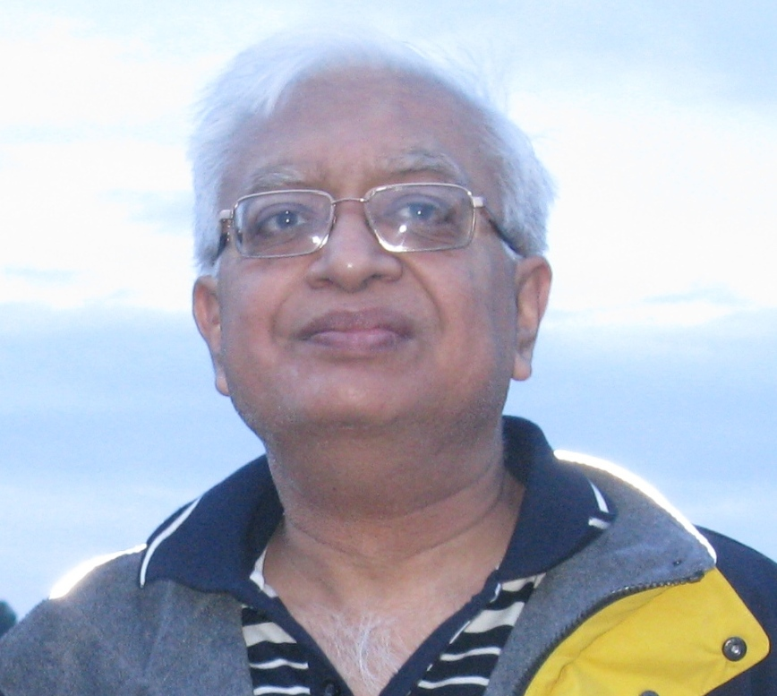
Prof P.K. Gupta

Prof Gupta, M. Sc, MBA and Ph D. is an ISM Dhanbad luminary who has been wearing several hats at the same time. He had been a Researcher at IIT, a CEO, a Corporate Trainer with global exposure, a bussiness analyst and a success coach. He was also the Dean, ICFAI Business School, Gurgaon - establishing B Schools at Noida, Jammu, Lucknow, Allahabad, Dehradun, Udaipur, Kota, Gwalior & Shimla.
He is a Consultant & Corporate Trainer, mastering the art of Case study methodology which he conducts with much interest, involvement and poise. He is always updated on the happenings in the Indian corporate tactics and International business. He envisions the market scenarios of the future for a crystal clear understanding by the students. His case studies bring up the latest upheavals of Indian corporate to the learners giving a cutting edge assessment and analysis - to understand the invisible intricacies of these mysteries.
With his international exposure in consulting he brings practical, simple yet powerful teachings in International Marketing, Consumer Behavior, Management Control System, Business Ethics & Corporate Governance, Political, Legal & Ethical Issues in Business, Environmental Science, Visioning and strategic Management and change management to the training room.
Although very much a Trainer at heart, Prof Gupta is also the Adjunct Professor, Associate Director and head of the Centre for Continuing Education, University of Petroleum & Energy Studies.

