H.K.Pahwa
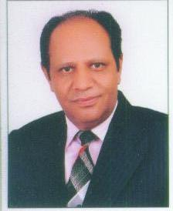
H K Pahwa is committed to transform professionals at all levels & ensure significant acceleration in their productivity & career advancement. He is a practitioner of experiential training for over 8 years.
In his illustrious career in the pharmaceutical industry & a multispecialty laser hospital, spanning over 24 years, he was entrusted with the responsibility of heading some of the most critical verticals namely:
Medical services, training & development, hard core sales, marketing, advertising, National medical conferences (Forums for customer relation building), constructing brand leaders through organization of symposia and HR function, in a pharmaceutical company ranked amongst first 5. He reciprocated the trust by leading from the front.
As a step towards recognition his passion namely training & development became his core responsibility. He is a proud winner of the ‘CMD Award for the Best Trainer’ for 7 years in a row. He has over 3000 days of training exposure with quantifiable results.
He is very proficient in handling large & small groups. Analysis & group presentation of in house case studies has empowered human capital in skill development. His induction training, workshops on recruitment, on the job induction of employees, motivation, market research, marketing research, brand positioning, channel management, leadership, quantitative performance appraisal and creative public speaking have always got the best of rating after the reaction level evaluation by the participants.
With a charismatic personality, grip over many languages, he successfully & quickly matches his wavelength with that of participants as he has conducted workshops from medical & sales representatives to senior managers.
His strong bottom line driven business acumen has been instrumental in restructuring some of the key strategic business units & in the development of innovative strategies towards generation of healthy bottom line.
Many corporations are availing benefits from his versatility.

