- Group Captain O Chandra Sekharam
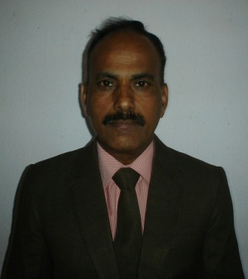
Gp Capt O Chandra Sekharam comes to TABI with over 30 years of experience in training and development and has contributed immensely in the enhancement of knowledge of Air Force trainees in the fields of personality grooming and general training and Development. He has served in the training establishments of the Indian Air Force for more than two decades and introduced many innovative techniques in improving the quality of training.
- He has been conducting training on Self-development & Learning programmes on Leadership, Valuing Human Resource, Creating a positive attitude, Induction of New Employees, Team Building, Succeeding with Assertiveness, Conflict Management Communication, Leadership & Supervisory Development, OD Intervention with Experiential learning Programmes.
- He has been Registrar, National Defense Academy, Pune, overseeing all aspects of training and development of more than 1800 cadet trainees at any given time.
- He served as Chief Instructor, Workshop Training Institute, Tambaram, Chennai which involved administering training and ensuring all round development of more than 2000 trainees.
- He was actively involved in the training of officer trainees at Air Force Academy, Hyderabad.
- He is a passionate trainer in personality development and art of facing interviews with recognized talents and sound reputation.

