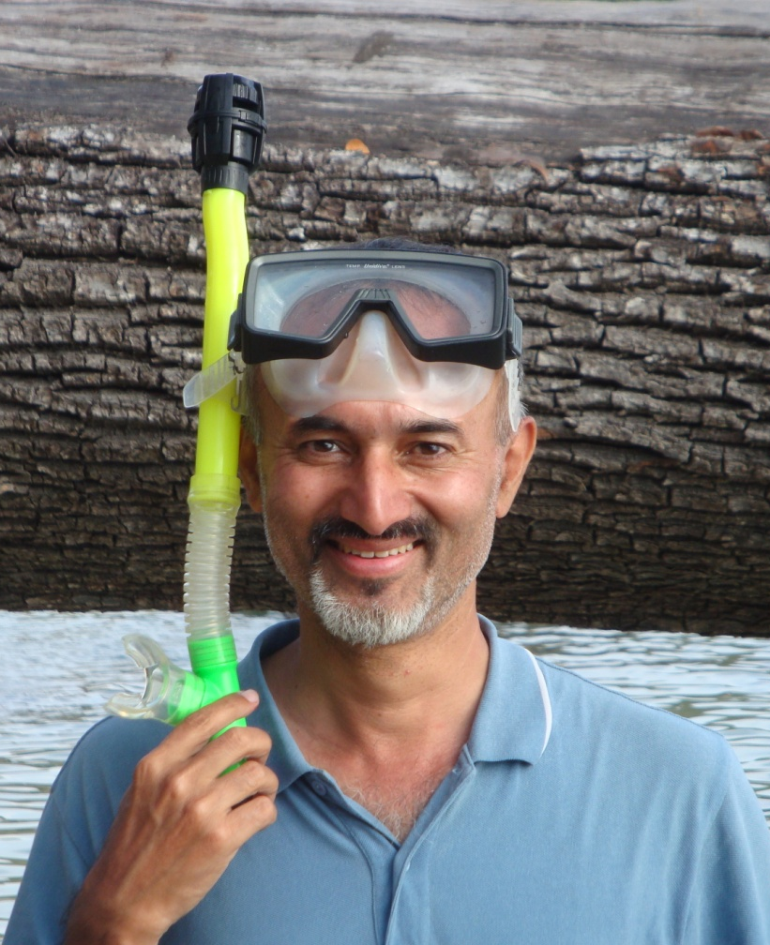
Akhil Kapoor

- A Masters in Strategic Management, Akhil Kapoor is an ex-IAF fighter flier who is a leading trainer for experiential learning in India. His diverse experience in behavioural coaching includes training with Oxford faculty and Israeli Defence forces.
- Over the last decade, he has designed and delivered Winning Leadership, Teambuilding, Strategic Innovation & Peak Performance modules, specially aligned to suite the Indian corporate texture.
- Akhil believes that activity based experiential-learning is 'stickier' and thus provides a powerful tool for creating lasting motivators for evolution. With special interest in growth behaviours, Akhil creates exciting options in break-through learning. One of the key programme dimensions being participants’ self-belief and ability to face leadership challenges to achieve ‘stretch goals’. To ‘exceed’ & evolve as synergetic teams & that’s a promise…delivered !

