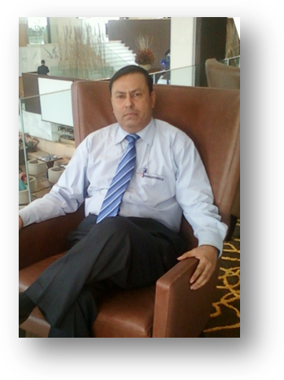
Wg Cdr S K Sharma
MD and Chief Mentor
Training And Beyond - India

Wg Cdr S K Sharma is the Managing Director and Chief Mentor of TABI (Training And Beyond-India), a specialist training company. He is a qualified trainer and a motivational guru. Backed by an Air Force career – spanning over two decades and a decade long stint in the corporate world, he is a visionary and incorporates the most modern training techniques in corporate and academic training. He had been the Head of a corporate business unit, Group Director HR of corporate house-managing a large task-force of over 18,000 employees.
- Throughout his corporate career, he has been conducting training workshops on Self-development, Leadership, Valuing Human Resource, Creating a positive attitude, Team Building, Succeeding with Assertiveness and selecting the best using Psychometrics in selection. His workshops are joyful journeys - full of Life experience, with appropriate psychometrics, served with a dash of Experiential learning.
- He has been a Senior Faculty at Defence Institute of Psychological Research and a selector, on the elite panel of Armed Forces Selection Boards and Indian Coast Guard - for almost a decade. He has also taught in many Management Colleges across Delhi & NCR.
- People from all walks of life - Business bigwigs, Entrepreneurs, Govt. Officials, Teachers, Doctors, Advocates, Pilots, Police Officers, Chartered Accountants, Defense services officers, Management Students and executives have benefited from his training workshops and consultancy.
- His Corporate Clients include companies from various sectors - such as Hospitality, Manufacturing, Automotive, Energy, Education, Service Industry, Finance & Insurance, Food & Beverages and IT .
- As a professional trainer of high credentials, he helps companies achieve their organizational goals faster, with ease and with visible results – providing ‘more’ value to learners.
- Contact:
    - trainbeyond@yahoo.in
md@tabi.co.in
+91 98868146804

