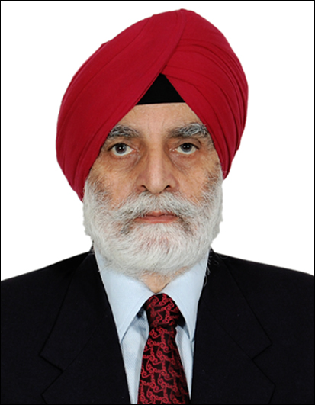

Major (Retd) Bikram Singh
Consultant & Trainer

Maj Bikram has been training Managers for Team Building, Leadership, Time Management, Security Awareness, Training of security personnel as per PSAR Act, and Emergency and Crises Management, for over a decade.
He provides consultancy to several companies on recruitment of personnel at various levels, background check & police verification, Training of security personnel & guards, Handling of surveillance equipment, Planning and deployment of security cover, Control and operation of command centers, Fire fighting and successful event management.
He has also helped several corporate houses on Workforce planning & fulfilling staffing needs, Specifying Jobs and roles, Upkeep of Infrastructure & Facilities Maintenance, Brand building and ensuring Top line Sales and Customer Relationship Management (CRM) - implementing the international practices in personnel and management - conforming to world class standards.

