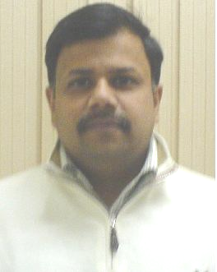
ANJANEY

- Anjaney is dynamic result driven professional with more than 15 years experience in Sales & Business Development, Team Management, Channel Management & Training with companies like Glaxo (I) Ltd and Pfizer Ltd.
- He is a multi linguist, conducting very lively and active training across the length and breadth of India. He is frequently invited by the ICFAI and other B Schools of Delhi & NCR for his special workshops for working professionals.
- A qualified trainer and coach, he is adroit at conducting training in - networking with reliable and financially strong channel partners for business excellence, developing new markets for launching new products, maintaining standards of excellence to overachieve expectations & sailing through targeted goals, Developing ˆ Excellent interpersonal, analytical & negotiation skills, developing new markets & launching products.
- He is adept at handling with great enthusiasm - smart ways of training for any age group, with his overflowing charm and experiential teaching methodology.

