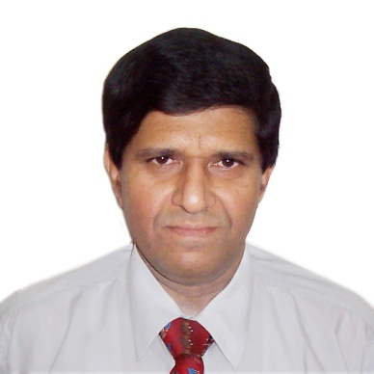
Anil Oberai
BTech (BIT Mesra), Lead Info-Security Auditor, Six Sigma (Green Belt),
QMS Professional, Specialist, IT Consultancy, Project Management,
Information Security & Risk Management, Six Sigma and
Lean Process optimization]

Anil Oberoi – An alumni of BIT, Mesra (Ranchi) had a glorious stint of over two decades in the corporates and he is now training and consulting for the past around 10 yrs. He is a Six Sigma Green Belt certified, BS7799 LA, C.I.I.S.A Information Security Auditor. He has also mastered the PMP PMBOK of PMI institute of Project Management Professionals, USA, & attended the skills development programs like Advanced Management Development program from XLRI, Jamshedpur ,Quality Education System (Phil Crosby) & SEI-CMM -3 for Software development, Oracle 8i Developer Certified Professional Course

A master at Information Technology Projects and Services – Anil has held several responsible positions like Vice president for a leading Smart cards Integrator ; GM (Systems) for a class A ISP; Head Business Processes Transition and Delivery for a leading U.S BPO; Project Head for a national e-Governance project; Chief Technology Officer (e-Services) and Project Head (Telecom Professional Services) .

Ably handling a number of Consultancy assignments he was the Pan India Project Director for Uninor, India’s Large Telecom operator’s 120 locations enterprise project for Security systems installation and commissioning.

Telecom Quality Management standard TL 9000 and ISO 27001 Process Audits for Business processes of Bharti Airtel Company’s operations, Network and corporate functions by incorporating detailed Questionnaire.

Information Systems Audit (CMM), Business process mapping for Vodafone India Telecom provider’s Customer, Billing and Systems operations processes.

Empanelled with Higher Learning institutions as Guest and Visiting Faculty for courses and workshops in Management Information Systems (MIS), Project Management Advanced Networks and Quality Management.

He loves sharing his vast experience with great passion – in his training workshops with the
young technocrats , business leaders and entrepreneurs.

